Aaron Jencks
1/22/2018
Communication Systems

Low Pass Impedance Transformation Networks Formal Report

Objective: To understand the concept of impedance matching for maximum power transfer.

Equipment:
- Digital Multimeter:
  - Model: U3401A
  - S/N: MY57300004
- Oscilloscope:
  - Model: TDS2024
  - S/N: C0404355
- Function Generator:
  - Model: Agilent 33220A
  - S/N: MY44049746
- Components:
  - Inductor (100uH)
  - Capacitor (4.7nF)
  - Resistors:
    - 4x 100 Ohm
    - 560 Ohm
    - 1800 Ohm

Method:
In this lab I studied the process of using low-pass filter networks to step-up or step-down voltage levels in a circuit. The first step was to calculate the required components. For the Step-down circuit, we used the data from figure 23.2 and we used equation 5 (L=(sqrt(Rl(Rd-Rl))/(2PIfin)) to calculate the inductor value. Then we used equation 10 (C=(sqrt(Rl(Rd-Rl))/(2PIfinRdRl)) to calculate the capacitor value. We then repeated this process using the values from figure 23.3 for the Step-up circuit. After that we calculated the impedance of the reactive components in each network and combined them, along with the load to determine the overall input impedance of each network.
Now that the components were calculated, we built the circuit from figure 23.2 and tested it at 10 frequencies between 100 and 1000 kHz, including the resonant frequency of 218kHz. Then we calculated the dB loss for the circuit at each frequency. We repeated this process for figure 23.3 as well (the step-up circuit).
Now we checked to make sure that the impedances we calculated earlier were correct by measuring the voltage drop over the input resistor for each network (see figure 1) and finding the frequency where the signal at the beginning of the circuit was in phase with the signal after the input resistor (called Vgen and Vin respectively). We then compared that frequency with the original frequency for accuracy.
Next we measured the voltage drops over the input series resistor, and the reactive network to verify that, at the resonant frequency, maximum power was delivered (equal voltage was dropped across each section) using the voltage divider rule.

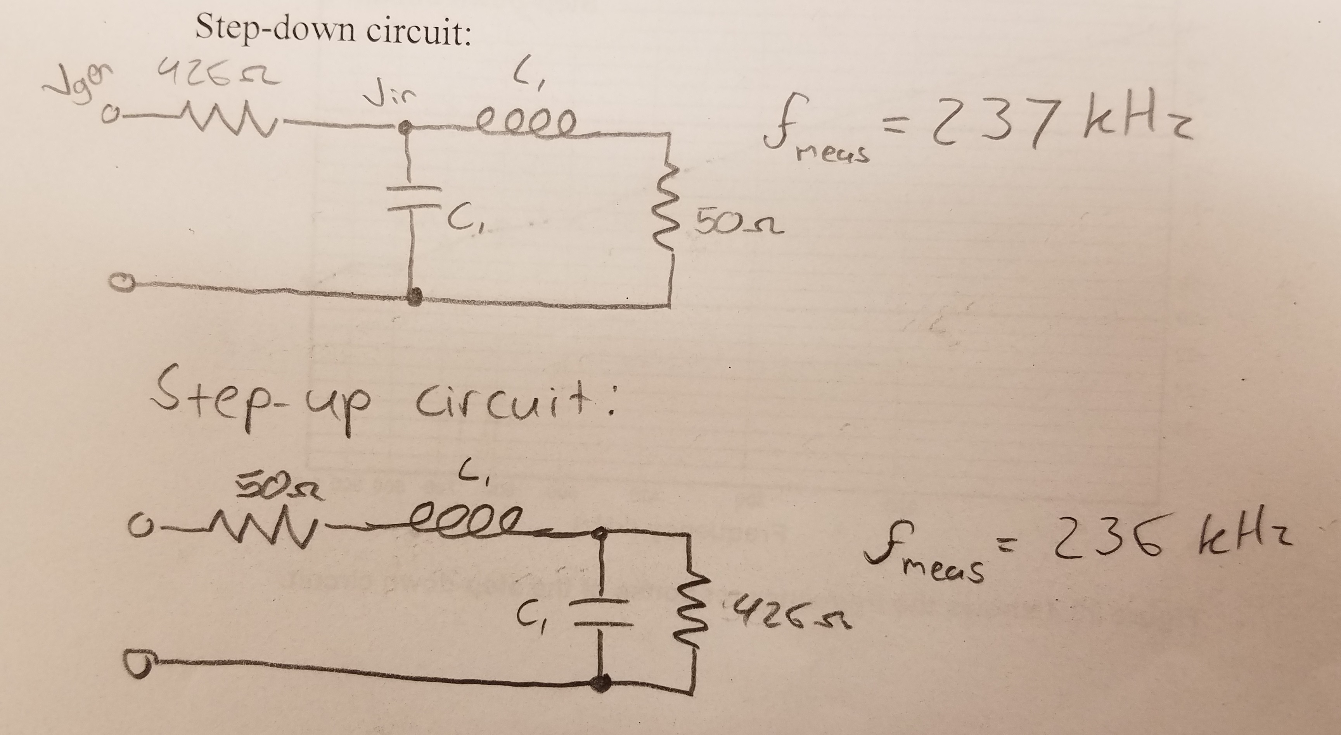
(Figure 1: Network setup for measuring the resonant frequency)

Results:
- Calculations:
  - Step-Up/Step-Down Inductor Value: 100uH
  - Step-Up/Step-Down Capacitor Value: 4.7nF
  - Step-Up/Step-Down Inductive Reactance Value: 137.11 Ohms
  - Step-Up/Step-Down Capacitive Reactance Value: 155.35 Ohms
  - Step-Down Input Impedance: 425.983+0.04i Ohms
  - Step-Up Input Impedance: 50+0.02i Ohms
- Vo Vs Frequency for Step-Down circuit:
Frequency(kHz) | Vgen(V) | Vin(mVpp) | Vo(mVpp) | Vo(dB)
100 | 1 | 200 | 122 | -4.3
200 | 1 | 420 | 164 | -8.2
218 | 1 | 470 | 170 | -8.8
300 | 1 | 512 | 140 | -11.3
400 | 1 | 342 | 72.6 | -13.5
500 | 1 | 246 | 42 | -15.4
600 | 1 | 194 | 30 | -16.2
700 | 1 | 160 | 22 | -17.2
800 | 1 | 133 | 16 | -18.4
900 | 1 | 115 | 14 | -18.3
1000 | 1 | 106 | 11 | -19.7
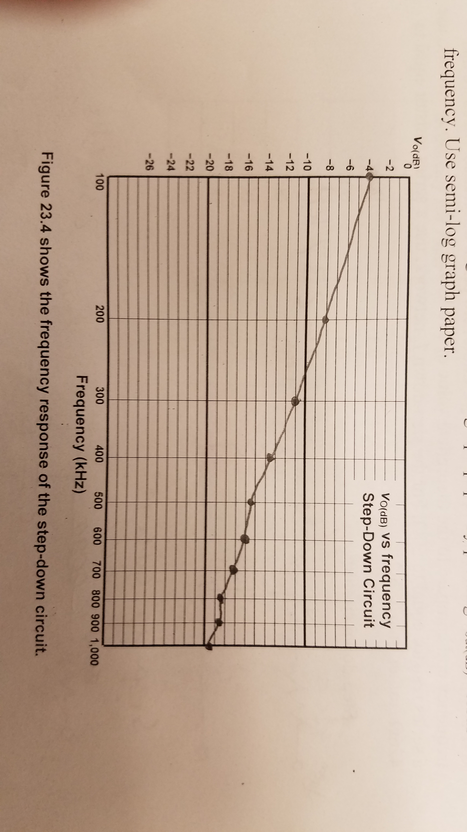
- Vo Vs Frequency for Step-Up Circuit:
Frequency(kHz) | Vin(mVpp) | Vo(mVpp) | Vo(dB)
100 | 920 | 110 | -18.45
200 | 704 | 140 | -14.03
218 | 656 | 144 | -13.17
300 | 730 | 120 | -15.68
400 | 970 | 65 | -23.48
500 | 1030 | 40 | -28.22
600 | 1050 | 27 | -31.8
700 | 1060 | 18 | -35.4
800 | 1080 | 14 | -37.75
900 | 1090 | 9 | -41.66
1000 | 1100 | 9 | -41.74
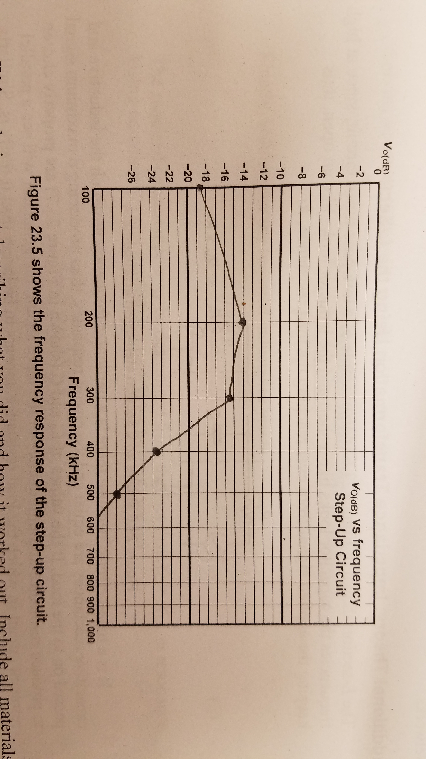
Conclusion:
There's tolerances in everything, and we showed that when we measure the actual resonant frequencies of the networks. We found that sometimes things don't work even though you followed the directions to a T, and when that happens, and sometimes there's nothing you can do about it.

